

Church Lane Primary School and Nursery
Attendance Policy
SEPTEMBER 2023

Introduction
This is a successful school and your child plays their part in making it so. We aim for an environment which enables and encourages all members of the community to reach out for excellence. For our children to gain the greatest benefit from their education it is vital that they attend regularly and your child should be at school, on time, every day the school is open unless the reason for the absence is unavoidable.

It is very important therefore that you make sure that your child attends regularly and this Policy sets out how together we will achieve this.

Why Regular Attendance is so important:

Learning: - Any absence affects the pattern of a child’s schooling and regular absence will seriously affect their learning. Any pupil’s absence disrupts teaching routines so may affect the learning of others in the same class.
Ensuring your child’s regular attendance at school is your legal responsibility and permitting absence from school without a good reason creates an offence in law and may result in prosecution.

Safeguarding: - Your child may be at risk of harm if they do not attend school regularly. Safeguarding the interests of each child is everyone’s responsibility and within the context of this school, promoting the welfare and life opportunities for your child encompasses:-
Attendance
Behaviour Management
Health and Safety
Access to the Curriculum
Anti- bullying

Failing to attend this school on a regular basis will be considered as a safeguarding matter.

The Law relating to attendance
Section 7 of the Education Act 1996 states that ‘the parent of every child of compulsory school age shall cause him / her to receive efficient full time education suitable to age, ability and aptitude and
to any special educational needs he/ she may have
Either by regular attendance at school or otherwise’

The Law relating to safeguarding
Section 175 of the Education Act 2002 places a duty on local authorities and governing bodies to have regard to guidance issued by the Secretary of State with regard to safeguarding and promoting the welfare of children and students under the age of 18.

Statement of intent:
The school aims to work together with parents/Carers to ensure that children of compulsory school age attend both regularly and punctually. Helping to create a pattern of regular attendance is everybody’s responsibility - parents, pupils and all members of school staff.

Understanding Types of Absence
Every half-day absence from school has to be classified by the school (not by the parents), as either AUTHORISED or UNAUTHORISED. This is why information about the cause of any absence is always required.
Authorised absences are mornings or afternoons away from school for a good reason like illness, medical/dental appointments which unavoidably fall in school time, emergencies or other unavoidable cause.

Unauthorised absences are those which the school does not consider reasonable and for which no “leave" has been given. This type of absence can lead to Sleaford Church Lane consulting the LA to use sanctions and/or legal proceedings. This includes:

- Parents/carers keeping children off school unnecessarily
- Truancy before or during the school day
- Absences which have never been properly explained
- Children who arrive at school too late to get a mark
- Shopping, looking after other children or birthdays
- Day trips and holidays in term time which have not been agreed.

Whilst any child may be off school because they are ill, sometimes they can be reluctant to attend school. Any problems with regular attendance are best sorted out between the school, the parents and the child. If your child is reluctant to attend, it is never better to cover up their absence or to give in to pressure to excuse them from attending. This gives the impression that attendance does not matter and usually make things worse.

Parents/Carers responsibilities:
Parents/Carers have a legal duty to ensure that children of compulsory school age attend on a regular and full-time basis.

Parents/Carers should ensure that, if their child is to be absent from school for any unavoidable reason such as illness, they should contact the school by 08:45am on the first morning of absence and on subsequent days of absence. This must be done by telephone on 01529-302696 (includes leaving a message on the absence line) or in person. Verbal messages on the parent’s behalf from an adult relative or representative such as a childminder or friend will not be accepted.
Parents may not authorise their child’s absence – only the school can do this, on the basis of the explanation provided by the parents. Should parents fail to provide a satisfactory reason; the school will record such absences as unauthorised. In some cases, this may be retrospective and authorisation may be withdrawn should circumstances arise leading the school to decide that the reason given was not truthful. If this occurs, this will be discussed with the parent.

Parents should ensure that their child arrives on time for the start of registration (between 8:30 and 8.45am).

At 8:45, the school gates will close. Children arriving to school after this point will be required to enter through the school office where you will need to give your reason for lateness.
Due to an increase in persistent lateness and after seeking guidance from Lincolnshire County Council, we will operate a persistent absence policy- where children who arrive late persistently, a fixed penalty fine will be issued. This is due to the disruption late children cause to their classmates but also because children are missing out on valuable learning time.

We will follow the traffic light system as follows:-
- Attendance Officer Reviews reports on a daily basis.
- Amber letter sent if a pupil is persistently late.
- If pupil is late again on a further occasion a Red letter will be sent.
- If any further occasions of lateness occur a Fixed Penalty Notice will be issued.

The law does not grant parents an automatic right to take their child out of school during term time. Any absence from school will disrupt your child’s learning.
Non-school attendance includes any day when a child should be in attendance at school and they are absent without the authorisation of the school and includes unauthorised holidays during term time and persistent late arrival at school beyond the registration period. Fixed Penalty Notices can be issued for persistent lateness where the child arrives after the closure of registration and will be enforced by Church Lane Primary School & Nursery from this point on as a result of the parent/carer being guilty of an offence under section 444 of the education Act 1996.
School responsibilities:
The school will record and monitor attendance in accordance both with the statutory requirements and with the principle that regular, uninterrupted attendance is vital to a child’s educational progress and personal wellbeing.
Registers will be taken twice daily (at 8.45am and 1:10pm). Gates will close at 8.45am and 1:10. Any child arriving after the close of the registration period will be recorded as “late” for that session.

Teachers will complete registers in accordance with guidance given by the Head teacher. The Head teacher will inspect registers weekly in order to ensure that they are being satisfactorily maintained and to identify any potential attendance problems at an early stage.

Should a class teacher have any concerns about a child’s attendance and punctuality, the Head teacher must be informed. This can be done in person
or via email. If the Head teacher has particular concerns regarding a child’s absence/wellbeing and no message has been received by the parent/carer, the Head Teacher (or an appropriate staff member in the Head teacher’s absence) and an appropriate member of staff may visit the home by 10.15am on the first day of absence. Other agencies may be informed/consulted if deemed necessary.

Should a child be absent, the class teacher will enter the child as absent on the register. It is the Headteacher’s responsibility to use the correct code for the absence. If no explanation has been received, the Headteacher will speak to the class teacher first and if there is still no explanation the Headteacher will endeavour to make contact with the parent.

If there are any absence notes from parents they should be dated and initialled by the class teacher and returned to the office with the register, where they will be stored. Only notes regarding absences where there are concerns need be brought to the attention of the Head teacher, who may then choose to speak to the parents.

The Head teacher will regularly collect attendance data and use this during meetings with the Attendance Officer. These meetings will agree on attendance thresholds and targets and will identify tasks and follow-up actions for both the school and the Headteacher. Other agencies, such as Children’s Services and Educational Welfare Officer (EWO) may also be involved.

Church Lane Primary School and Nursery will employ a number of strategies to promote regular attendance, including: appropriate personal encouragement for particular children; termly and annual certificates and prizes.

Persistent absentees:
Persistent absentees are defined as children whose attendance is below 90% and where unsatisfactory reasons are given for absence. However, the procedures outlined below may apply to children whose attendance is above 90% but where there are concerns about deteriorating attendance or where patterns are emerging,
e.g. regular absences on particular days or persistent lateness.
All of the above policy applies to persistent absentees, with the following additions:
· Children’s names are highlighted in the Absence File in the front office.
· Any messages received regarding absence of these children are recorded on Integris.

· If no message is received, either the office staff or Headteacher must be informed and must attempt to contact the parent at the earliest opportunity. If no contact is made or the message received is unsatisfactory a home visit will be conducted on the first day of absence. The Educational Welfare Officer (EWO) and other agencies may be informed/consulted if deemed necessary.

Church Lane Primary School and Nursery Target:
The school has targets to improve attendance and your child has an important part to play in meeting these targets.

The minimum level of attendance for this school is 96% attendance and we will keep you updated regularly about progress to this level and how your child’s attendance compares.

Our target is to achieve better than this however because we know that good attendance is the key to successful schooling and we believe our pupils can be amongst the best in the County.

Through the school year we monitor absences and punctuality to show us where improvements need to be made.

Information on any projects or initiatives that will focus on these areas will be provided in our Home - School Newsletter and letters sent home to individual parents/carers and we ask for your full support.

Summary
The school has a legal duty to publish its absence figures to parents and to promote attendance. Equally, parents have a duty to make sure that their children attend.

All school staff is committed to working with parents and pupils as the best way to ensure as high a level of attendance as possible and that every child’s welfare and life opportunities are promoted.

Appendix 1 – First Day Contact Guidelines

First day contact is a widely used practice in schools and has been shown to improve attendance rates. The correct procedure at Church Lane is as follows:

1. As soon as the registers are returned to the office, the office staff check absentees against messages received via letter, email from teacher or via school absence line.

2. For persistent absentees, see the relevant section above. For other pupils for whom no message has been received, the office staff will attempt to make contact with the parent at the earliest opportunity.

3. When contact is made, the parent will be asked for the reason for absence. In the event that no proper reason is supplied, the parent will be informed that the absence will not be authorised.

4. In the case of minor ailments, the parent will be encouraged to send the child in with an assurance that school will keep a close eye on him/her. (NB – if there has been a spate of certain symptoms in the school or community, such minor illnesses may be treated as a valid reason for absence).

5. Where no contact is made, a message should be left asking the parent to contact the school. Where it is impossible to leave a message, a letter should be sent following this up. In this instance a home visit may be conducted before 10am on the first day of absence by the Headteacher and an appropriate member of staff.

6. Reasons for absence are then added to the register.

Appendix 2 – requesting leave of absence in special circumstances

Regular school attendance is essential if children are to maximise their educational opportunities. Interruptions in school attendance disrupt continuity of learning and have a negative impact on attainment.

It is the school’s responsibility to provide the best education possible. We can only do this if child/ren attend regularly. There is a direct correlation between achievement and attendance.

The Government’s guidance states that only under special circumstances may the Headteacher consider giving permission for a child to be absent from school for a maximum of 10 days in any one school year. In line with national and local guidance the school would like to outline clearly when permission will not be granted:-

· During transition time as a pupil is settling into the school.
· Before or during Year 6 SATs or important revision periods leading up to
these.
· If the pupil has attendance below 95 %.
· If the pupil already has unauthorised absences.
· From September 2013, the school will not authorise requests for term-time holidays even when the above criteria do not apply.

Section 444(A) of the Education Act 1996 empowers the local authority to issue Penalty Notices for failure to ensure regular school attendance. Parents or carers who take their children on holiday in term time without school’s permission or are late returning from an extended holiday, may receive a Penalty Notice fine of £60 per parent per child, which must be paid within 28 days. If payment is made after 28 days but within 42 days, the penalty is increased to £120. Where a fine remains unpaid after 42 days, the matter will be referred to the County Solicitor, who will consider instigating criminal proceedings.

Please note that Penalty Notices can be issued after 10 unauthorised absences in a 12-week period – this is 10 registration periods, i.e. 5 days. Children who are late without good reason after registration closes (8:45) also receive an unauthorised absence mark. The 2007 regulations also set out the procedures for issuing Penalty Notices (fines) to each parent who fails to ensure their children’s regular attendance at school or fails to ensure that their excluded child is not in a public place during the first 5 days of exclusion. Parents must pay £60 if they pay within 28 days or £120 if they pay within £42 days.

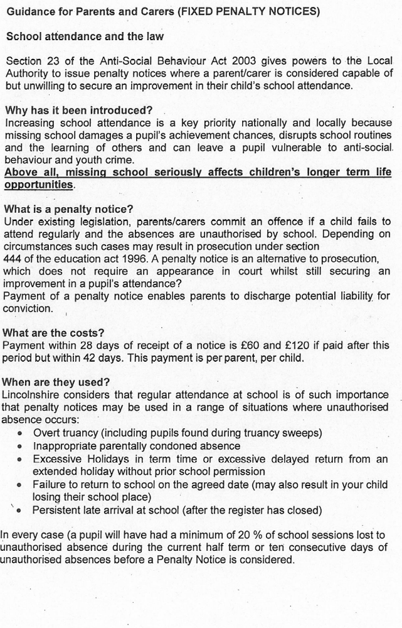

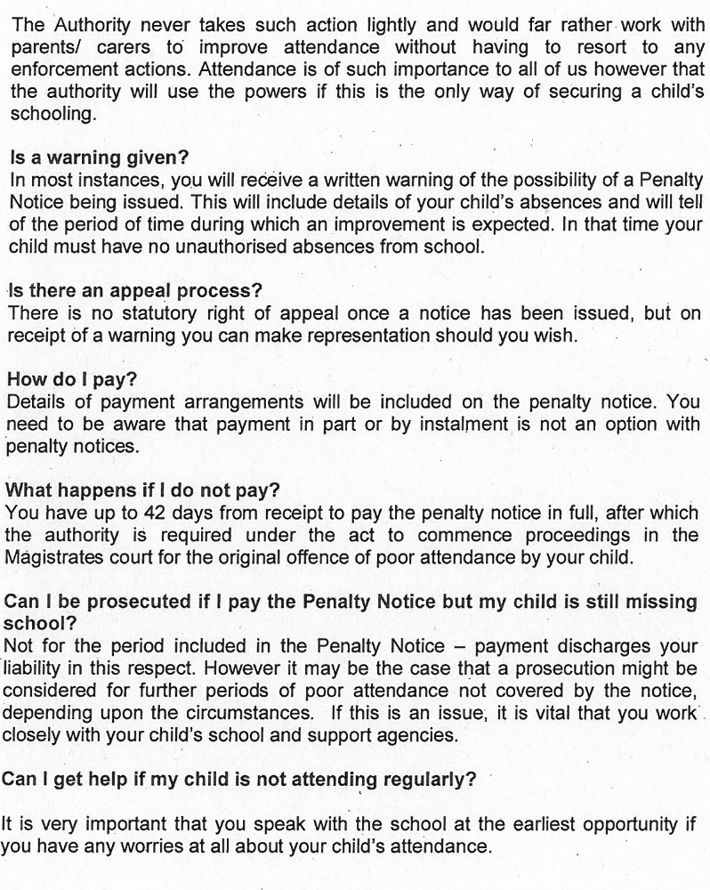

Appendix 3:

TRAFFIC LIGHT MONITORING SYSTEM

SCHOOL STRATEGIES / INTIATIVES

These strategies are proven and attendance at another school that implemented them found there attendance level rise from 89% to 96%

- High profile attendance board highlighting 95% - 100% attendees

- Certificates given at assembly by the Headteacher each half-term for attendees with 96% - 100% attendance

- Class prize for full 100% attendance at the end of the school year

- Attendance weekly draw for 100% attendees (Small prize)

TRAFFIC LIGHT SYSTEM

Everyone receives a copy of our attendance policy when they join the school and this can also be found on our website.

Attendance officer reviews reports on a weekly basis

- Attendance 96% or above NO ACTION
- Below 96% FIXED PENALTY FORMAL WARNING LETTER with new target.

WAIT FOUR WEEKS

- Target not met – FIXED PENALTY NOTICE SENT TO PARENT AND LCC, LCC WILL PROCESS A FINE.
- New cases below 96% PERSISTENT ABSENCE NOTICE WARNING LETTER with new target

TRAFFIC LIGHT MONITORING SYSTEM
FOR LATENESS

TRAFFIC LIGHT SYSTEM

- FIXED PENALTY FORMAL WARNING LETTER - SENT IF PERSISTANT LATENESS OCCURS.

MONITOR FOR ONE WEEK.

- SECOND FIXED PENALTY FORMAL WARNING LETTER IF LATENESS CONTINUES AND OCCURS 3 TIMES OR MORE IN ONE WEEK.

MONITOR FOR TWO WEEKS.

- FIXED PENALTY NOTICE SENT TO PARENT AND LCC, LCC WILL PROCESS A FINE.

Written by: Callum Clay

Review date: September 2024

